Old milk jug

[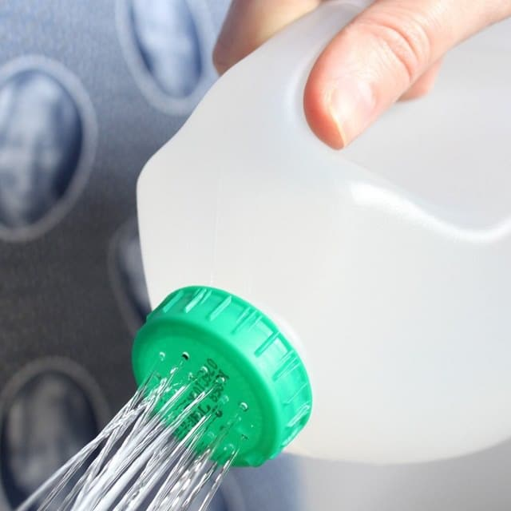](https://balconygardenweb-lhnfx0beomqvnhspx.netdna-ssl.com/wp-content/uploads/2016/06/No-watering-can-No-problem.jpg)

This super simple hack of an old milk jug is perfect for a new gardener that hasn’t gone out and bought a watering can yet. Just upcycle your old plastic milk jug by heating up a needle and poking holes in the lid so water can flow through it freely.